📝 Notes
May 4, 2026

Contained Animal Management System | Design Review 2
Invited Christian Ruiz Francisco Perez Tyler Morton Raul Montenegro Claudiu Constantin wyldsolconsulting@gmail.com
Attachments Contained Animal Management System | Design Review 2
Meeting records Transcript Recording

Summary
Design reviews covered onboarding flows and subscription tiers with refined inventory management and interface navigation adjustments.
Onboarding and Subscription Flow
The team refined the onboarding process to include a paid partner tier and opted for a yearly-only billing model. They decided to move the inventory import feature to the dashboard setup checklist to reduce friction.
Interface and Feature Adjustments
The ranch view was removed from the minimum viable product to improve reporting metrics. Inventory tables will utilize paging to handle large datasets effectively.
Visual Direction and Refinement
Stakeholders approved the overall aesthetic while requesting more subdued colors for the table views. The team also finalized a filter strategy to better manage active versus sold animal status.

Rate this Summary: Helpful or Not Helpful

Decisions
We've updated the Decisions section using your feedback.
Let us know what you think: Helpful or Not Helpful

ALIGNED
- Partner/view-only subscription tier A 'Partner' tier will be added to the subscription options to accommodate read-only access for users.
- Yearly subscription billing only Subscription billing is set to yearly only for the MVP launch.
- Inventory filter options Inventory filtering will include 'Type' and 'Status' as primary filter options.
- Ranch view page removal The 'Ranch' view page is removed from the MVP, with relevant data shifted to the dashboard and reporting pages.
- Inventory status filter categories Inventory status filtering will support system statuses including 'Active', 'Retired', and 'Sold'.

Next steps
- [Claudiu Constantin] Review Comments: Check WyldSols comments left on the designs after the current meeting.
- [Claudiu Constantin] Fix Text: Correct design text based on WyldSols feedback.
- [Claudiu Constantin] Note Developers: Leave a comment for developers regarding testing the import feature onboarding friction.
- [Claudiu Constantin] Add Tier: Include the Partner or Tier 0 plan into the subscription selection flow.
- [Claudiu Constantin] Update Pricing: Change subscription payment display to reflect yearly payment upfront.
- [Claudiu Constantin] Add Notifications: Include mobile notifications feature in the design.
- [Claudiu Constantin] Update MVP Screens: Create screen version without the Ranch view or generate invoice functionality. Shift associated metrics into the Financials and Reports pages.
- [Claudiu Constantin] Update Filters: Surface Type and Status filters in the Inventory view.
- [Claudiu Constantin] Refine Colors: Play around with secondary pastel colors and potentially leave a note regarding color choices for quick actions.
- [Claudiu Constantin] Build Overlay: Build the inventory table overlay for multi-selection actions and add dummy actions like adding to events.
- [Claudiu Constantin] Repurpose Metrics: Repurpose summary metric fields to display meaningful data like Sold animals based on inventory status.
- [Claudiu Constantin] Continue Design: Apply all relevant feedback and continue working on the rest of the flow, specifically Media and Competitions pages.
- [Francisco Perez] Schedule Meetings: Coordinate schedules for 2 pending meetings and send invitations later today.
- [Francisco Perez] Discuss Deliverables: Discuss documentation preparation and final designs status with Tyler regarding the deliverables meeting next week.

Details
Did the screenshots in this section make your notes better or worse?
- Design and Visual Direction Updates: Claudiu Constantin presented design changes incorporating feedback, including the use of more earthy tones and color, and removing an image in favor of highlighting features (00:00:00). They will review existing comments from WyldSol, specifically regarding invoicing, and will fix text issues (00:01:21).
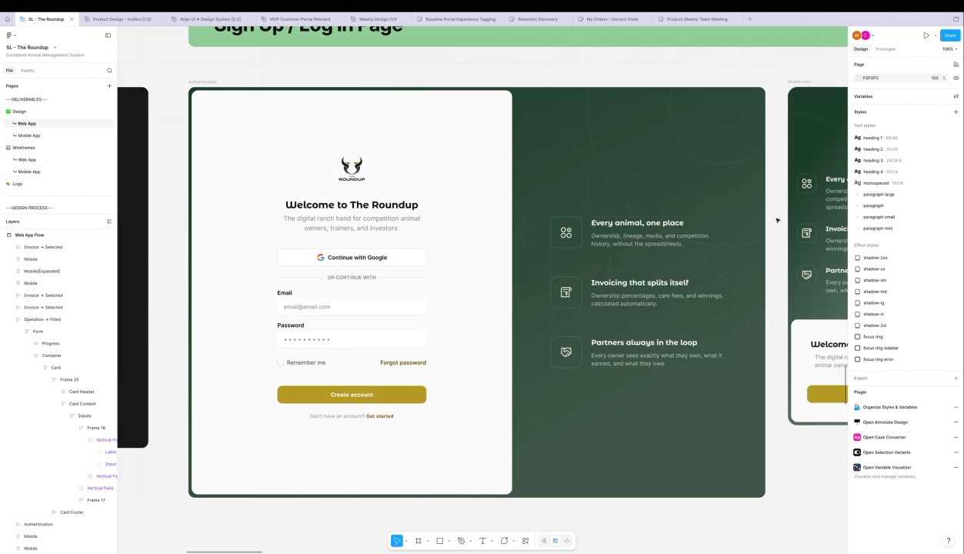
- Onboarding Flow and Account Creation: The onboarding process was detailed, including basic account creation and a potential step for OTP validation to verify email, which would occur before collecting basic user information. They noted a potential area of confusion regarding the ordering of collecting animal inventory before asking the user to select a subscription tier, which WyldSol pointed out felt "backwards" (00:02:24).
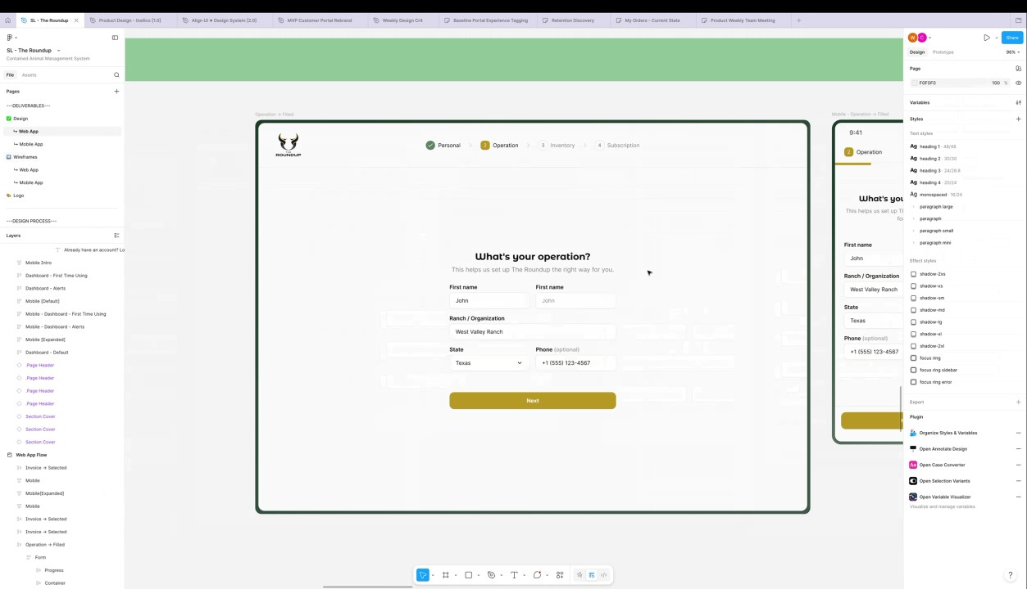
- Inventory Import Feature Discussion: The bulk import feature for inventory, such as animal rosters, was discussed, with Claudiu Constantin explaining their rationale for recommending a subscription based on the detected animals after an upload (00:02:24). They acknowledged WyldSol's concern that the bulk import may not be robust enough for mobile and agreed that it might be an exclusively web-based feature, though Claudiu Constantin will leave it in the design for testing (00:04:03). They concluded that if the import feature creates too much friction during onboarding, it can be removed and made available later on the dashboard setup checklist, allowing users to focus on subscribing first (00:05:18).
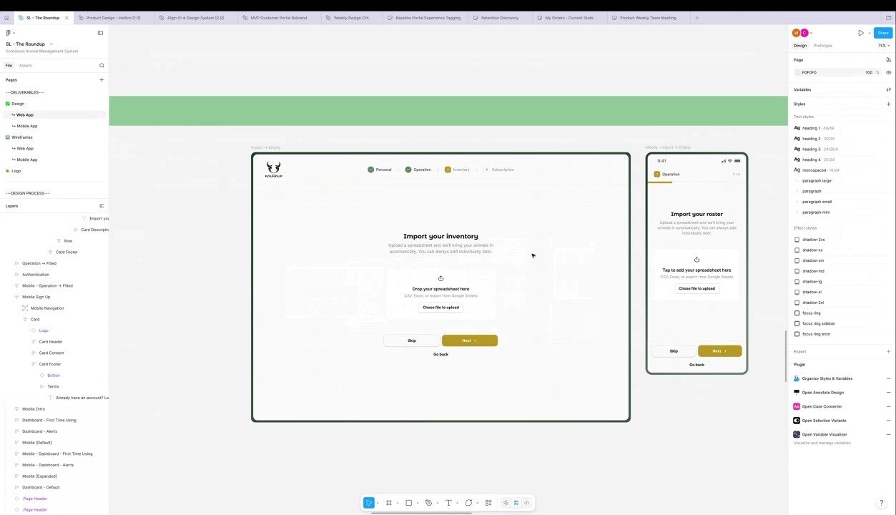
- Subscription Tiers and Partner Accounts: Claudiu Constantin added placeholders for different subscription plans and addressed the partner/view-only tier requested by WyldSol. They initially planned to skip the view-only tier from the main flow because partners would be invite-based and use a different process, but WyldSol clarified that partners might work with multiple ranches and need a view of their own animals (00:06:38). WyldSol confirmed that the "Tier Zero" for partners is not a free tier and that stakeholders require charging for it (00:08:06).
- Subscription Plan Details and Payment: Claudiu Constantin agreed to add the partner-focused Tier Zero back into the manual sign-up flow, noting that partners will need to pay but will not be able to add animals. WyldSol specified the cost is yearly, approximately 200, which led to a discussion about whether to offer a monthly versus yearly payment toggle, ultimately deciding to change the payment option to yearly only (00:09:16). The process requires users to confirm the yearly subscription and add card details for automatic withdrawal, with Claudiu Constantin confirming the card details would be saved (00:11:41).
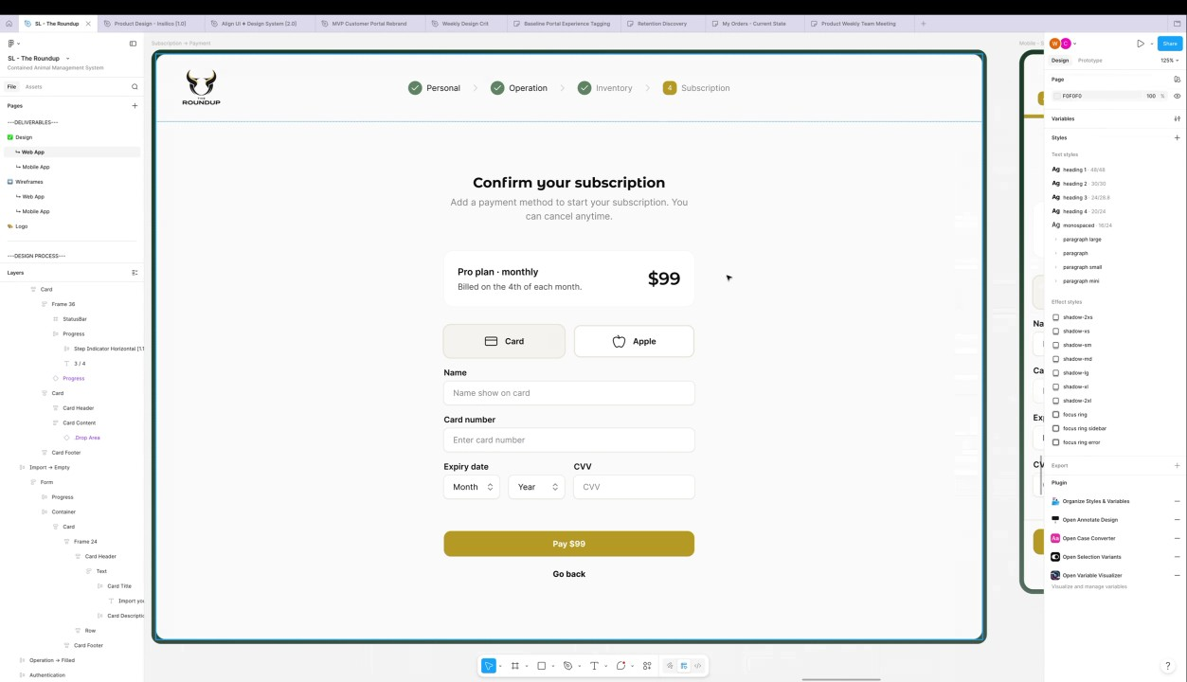
- Tier Upgrades and Subscription Limits: WyldSol raised a question about the workflow for upgrading tiers if a user adds more animals, prompting them to exceed their current plan limit (00:11:41). Claudiu Constantin confirmed that the platform will not show the upgrade prompt during initial onboarding but will display a prompt to upgrade once the user hits their animal limit. The payment processing will include a success screen with a receipt and a reminder of the active subscription before taking them to the dashboard (00:12:35).
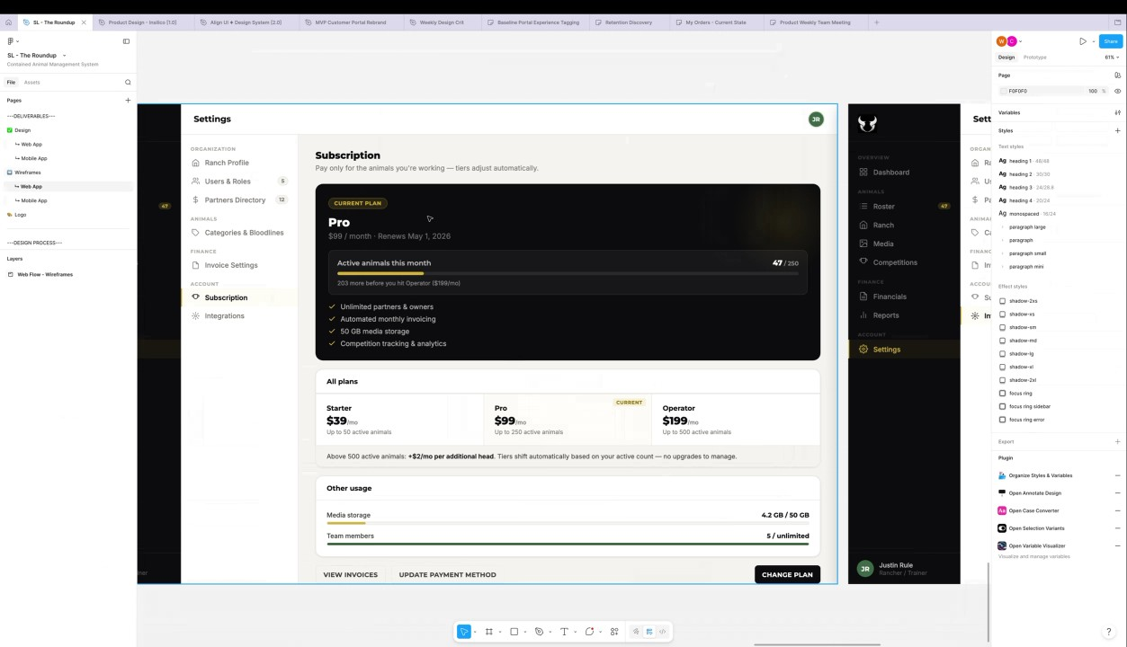
- Initial Dashboard View and Navigation: For day-one users, the dashboard will display an empty state with a setup checklist, including steps like filling out ranch details, importing inventory, inviting a partner, and setting fees. Claudiu Constantin outlined the mobile interface, which includes quick actions and a bottom navigation bar focusing on four core elements (home, inventory, ranch, media) with the rest nested under a 'more' button, but they noted that notifications for mobile are currently missing and need to be added (00:14:04).
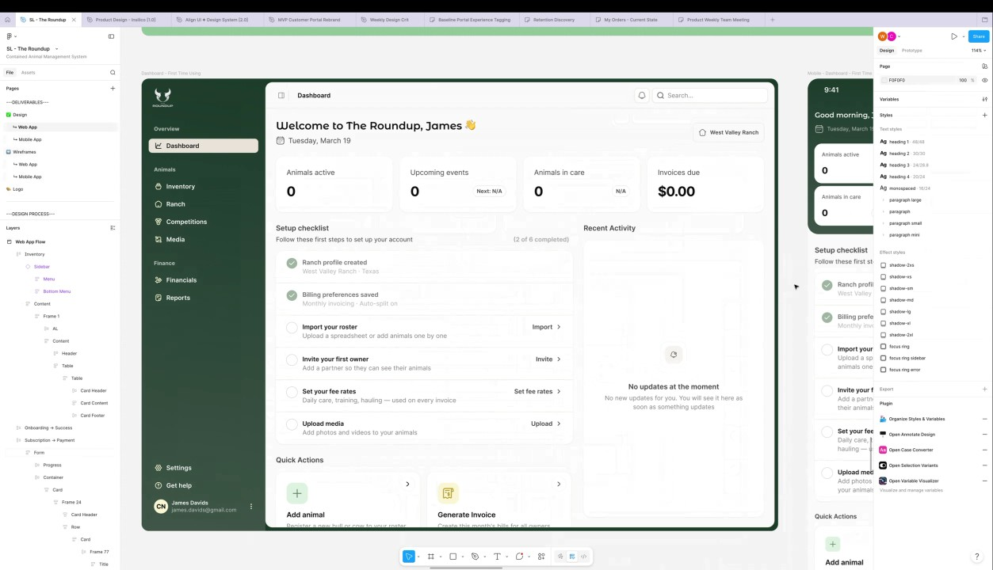
- Dashboard View with Activity and Alerts: The dashboard for existing users will fill out with data, including recent activity such as cows added to events and recent media (00:15:29). Claudiu Constantin intentionally included elements like invoicing and competition data in the current visual layout for reference, though they will create a separate MVP-specific version without them (00:16:47).
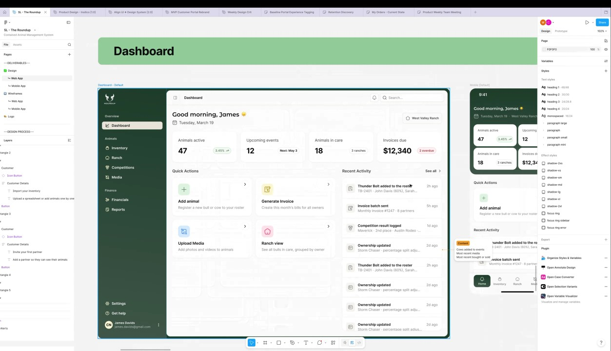
- Inventory View and Filtering: The inventory section includes a summary of active and inactive animals, with options to import, export, and add a new animal. Claudiu Constantin plans to surface the animal type and status as primary filters, while secondary filters such as location and bloodline will be hidden (00:18:11). The display table will list the animal name, type, bloodline, location, primary owner, and status (00:19:22).
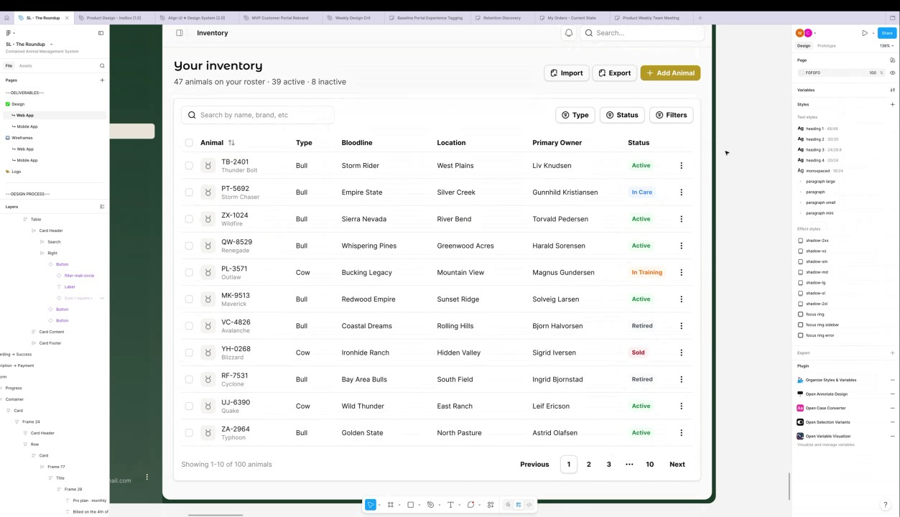
- Inventory Table Functionality and Paging: WyldSol confirmed that they are using paging for the inventory table view rather than a continuous scroll due to the potentially large list size, which Claudiu Constantin noted would require a state-saving approach to maintain selection across pages (00:19:22). Christian Ruiz confirmed the approach is correct. The discussion concluded that users would likely filter down results before selecting all items, though Claudiu Constantin is accounting for edge cases (00:20:38).
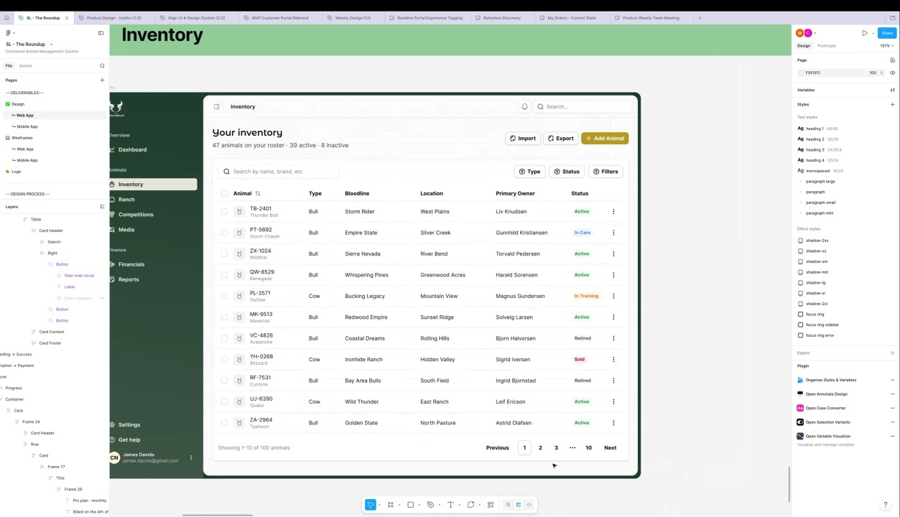
- Visual Direction and Color Feedback: WyldSol approved the overall visual direction but expressed a dislike for the secondary pastel colors, specifically the light blue and pink used in the design (00:20:38). Claudiu Constantin noted that some colors need to be more "tamed," particularly for table views, to prevent distraction and agreed to play around with different background colors for quick actions (00:21:42).
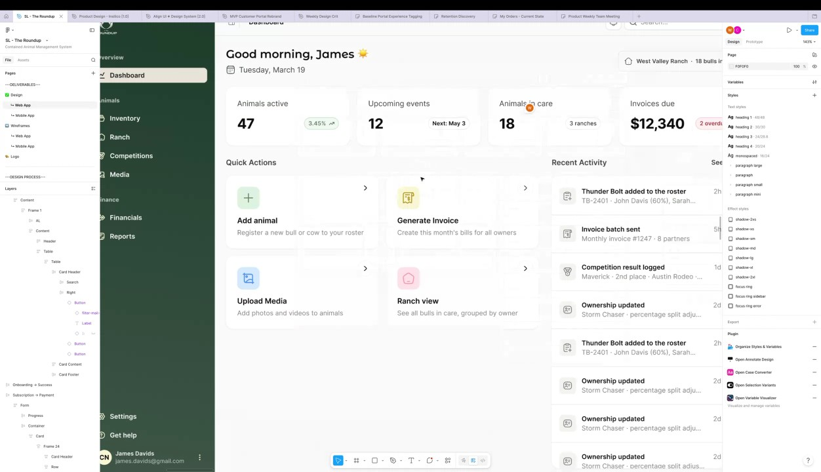
- Ranch View Removal from MVP: The group discussed the 'Ranch' view, and WyldSol suggested pushing that information to the reporting features, stating that the current ranch view does not align with their mental model of ranch management. Claudiu Constantin agreed to remove the Ranch page from the MVP, noting that some of its metrics will be shifted to the dashboard and reporting page (00:23:18).
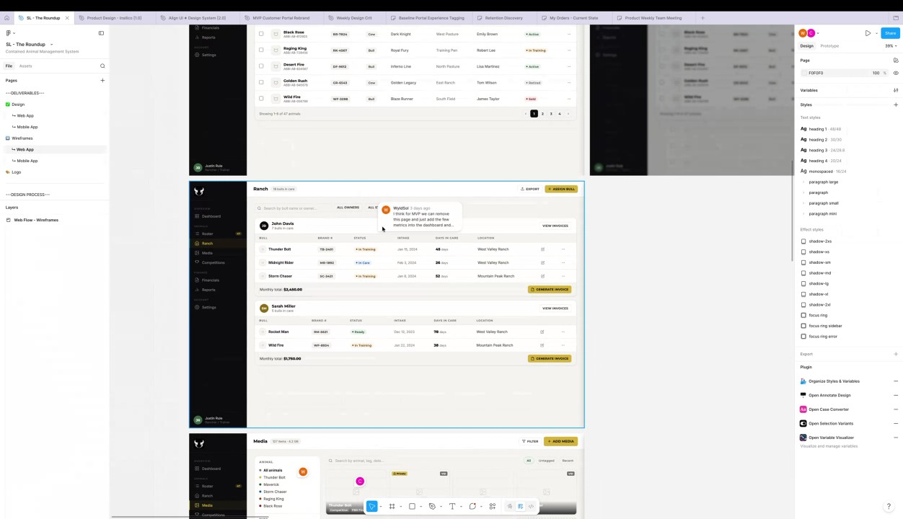
- Inventory Summary Metrics: WyldSol questioned the purpose of the 'animals in care' metric on the inventory summary, prompting a discussion about using system statuses like active, sold, and retired (00:25:47). Francisco Perez suggested that the metric should aggregate animals that are not active, such as retired or sold animals, as a quick filter. The group agreed that a quick filter for "sold animals" would be valuable, as these are "snapshot animals" that users no longer own but may still need to reference in inventory (00:27:05).
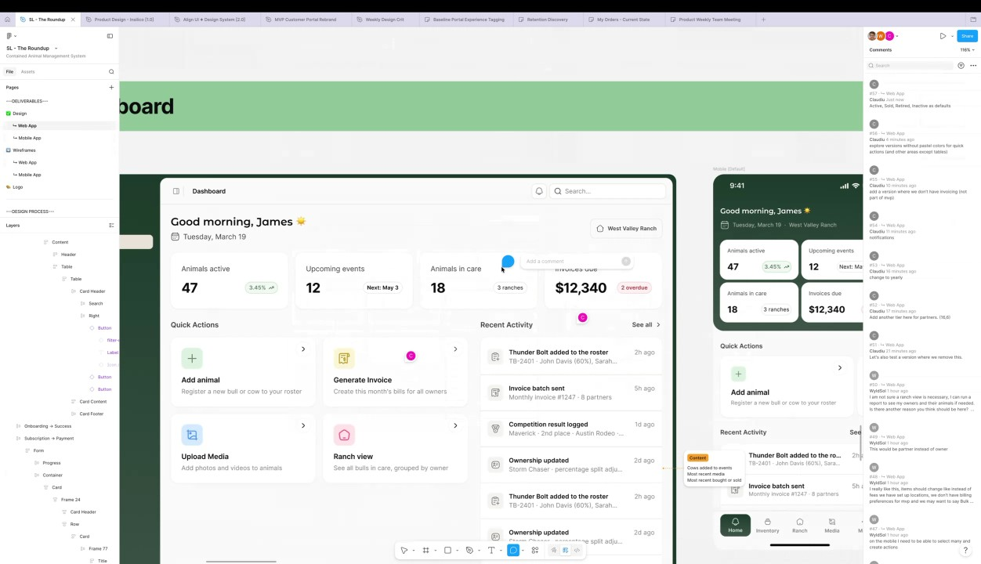
- Next Steps for Design and Development: Claudiu Constantin committed to applying the feedback, continuing the rest of the main flow designs (inventory, media, and competitions), and confirmed they have already noted the feedback on competition element removals (00:28:07). Claudiu Constantin then announced they were dropping off the call but would catch up later regarding priorities (00:29:13).
- Scheduling Meetings for the Week: Francisco Perez requested WyldSol's availability for one-hour meetings on Tuesday, Wednesday, and Thursday, noting that Thursday is not a holiday for WyldSol (00:29:13). WyldSol provided time windows for those three days. Francisco Perez will use this information to coordinate schedules and send out invites for the two pending meetings later that day (00:29:58).
- Deliverables Meeting Scheduling: Francisco Perez mentioned that WyldSol would receive an email from Tyler later in the week regarding the deliverables meeting, which is tentatively scheduled for early next week. Francisco Perez will discuss the preparation of documentation and final designs with Tyler to confirm the date and send out the calendar invite beforehand (00:29:58).

You should review Gemini's notes to make sure they're accurate. Get tips and learn how Gemini takes notes
How is the quality of these specific notes? Take a short survey to let us know your feedback, including how helpful the notes were for your needs.

📖 Transcript
May 4, 2026

Contained Animal Management System | Design Review 2 - Transcript

00:00:00

Francisco Perez: uh try to cover the updates in the first half an hour and then we want to discuss some of the next steps to schedule the meetings for this week. Um but yeah, let's begin with the with the review. Go ahead, Chloe.
Claudiu Constantin: Just a second to share my screen. Um, I saw already g uh left some comments uh but I'm going to check them after the call. Um
WyldSol: Okay.
Claudiu Constantin: actually, okay, I see. Seems like punctual. So maybe if there's time at the end, we can go over them um and actually fix some of them if there's any clarifications of any if that's okay.
WyldSol: Okay.
Claudiu Constantin: Um all right. So, as you've noticed, uh I did change the design a bit to include the mentions that I had from my last design review. So, more more earthy tones, uh more color, more uh it's a bit more bold in certain areas, and I think uh it fits nicely with the brand as well. Um,
WyldSol: Yeah.
Claudiu Constantin: I decided to remove the image in favor of uh features since we don't really mention them in the beginning.

00:01:21

Claudiu Constantin: Uh, excluding the website, of course, for landing page when that's going to be up. Uh, I already saw a comment that you've left regarding invoicing. I already started removing certain parts of the invoicing for NVP. I'm not removing the screens themselves. I'm still keeping them in an archive just in case we circle back on those.
WyldSol: Okay.
Claudiu Constantin: We we will have them. Um but that's that noted on this. I did see you leave you left a comment for different texts. So I will fix that afterwards. And for each of the screens that we're going to go through, I also left a mobile version uh next to it.
WyldSol: Yeah, I saw
Claudiu Constantin: In some situations, we might have a split.
WyldSol: that.
Claudiu Constantin: So, for example, in this, since we don't really have place for both of them, we're going to have a splash in the beginning with a welcome. You press next, and then you choose by default, you create an account or you log in. Um, creating an account.

00:02:24

Claudiu Constantin: This should be already detailed. Once you filled this out uh with the basics, uh we're still thinking if you want to have an OTP validation as well. So just to send a code to validate their email um that could go in between these two steps. If not, then we can jump straight to the first step which is a bit uh basic information about the information as you saw in the wireframes. Uh I did notice briefly you left a comment about some confusion here. So we can clarify that now if you
WyldSol: Yeah. So, it was going um we have them add their
Claudiu Constantin: want
WyldSol: animals and then we say, "What tier do you want?" And I felt that was kind of backwards.
Claudiu Constantin: check here. Yeah. Uh actually let me reach that spot. So here inventory import your uh inventory let's say roster
WyldSol: Yeah.
Claudiu Constantin: inventory let's update this my idea was that once they update and since we were going to have like a very streamlined flow this is a testable thing because I'm not going to be 100% sure it's subjective but uh in my mind my my logic was that once they upload we can actually detect what type of animals they have and we can just recommend uh the subscription that they need.

00:04:03

Claudiu Constantin: Otherwise, can be a fit, but that might create some friction. Let's say that they're taking their time to fill out everything and then reaching the subscription phase. But that should technically not be a surprise if they're coming from the website because they know it's not free.
WyldSol: Yeah.
Claudiu Constantin: But again, it might be certain friction that the setup takes too long and they won't see the platform. But it is a choice in the end because this step is skippable.
WyldSol: Heat. Well, I don't know.
Claudiu Constantin: Uh
WyldSol: I know you have this piece on the mobile as well, and I'm not sure I don't I don't think
Claudiu Constantin: yeah,
WyldSol: they're robust enough to have Yeah,
Claudiu Constantin: importing might be harder here.
WyldSol: I don't think they would have that at all. So, I think the only way we offer that bulk import is on the
Claudiu Constantin: Yeah.
WyldSol: web.
Claudiu Constantin: Yeah. I was hoping we could have it for mobile as well, but indeed it could be tricky. I'm going to leave it anyway just to see once I reach that step cuz if it's clear enough, yes, we manage a lot of numbers like not numbers but rows in general elements.

00:05:18

Claudiu Constantin: Um but I'll see um your point is valid though. In the worst case scenario, we can simply split them and have this remove this from the on boarding totally to be honest if that creates a lot of friction because they will they be able to do it uh from the homepage uh dashboard as as well since we have a setup checklist ongoing which they will follow
WyldSol: Yeah. Yeah.
Claudiu Constantin: and ultimately they will see this and they will have to
WyldSol: Like
Claudiu Constantin: do every one of these steps or we will just bug them forever. Um, I'm going to leave my comment here for myself. Let's I'm going to leave a comment for developers here in in testing once I have the onboarding uh or the import feature done as well. we can see if it makes sense or not to like if there's too much friction then we can just remove it and let them do it
WyldSol: Okay.
Claudiu Constantin: afterwards so they can focus on subscribing first cuz
WyldSol: Okay.
Claudiu Constantin: that's technically like the most important step then they can set do their stuff uh all right then let's say

00:06:38

WyldSol: Yeah.
Claudiu Constantin: they import their animals they select a plan I just added some placeholders here uh with simple data I know that in your comment you had a view mode only tier which was only for partners. My reasoning for skipping that here is because they will be on invite based and they will have
WyldSol: Yeah.
Claudiu Constantin: a different slide flow uh than this.
WyldSol: So they they should well
Claudiu Constantin: That was my reasoning for not adding it here because technically we invite them. It's only read only. So they don't really need a platform per se. They log in into others platforms or at least in a mock view mode platform only.
WyldSol: But they could be working with two.
Claudiu Constantin: Um,
WyldSol: So I could be a partner of your ranch and um Joe's ranch, right? So Joe could have some of my stuff and you could have some of my stuff, but when I get into mine,
Claudiu Constantin: yeah.
WyldSol: I see animals that you have one through five and the animals that Joe have 6 through 10. So it's really my view of my animals that many people may have.

00:08:06

WyldSol: Does that make sense?
Claudiu Constantin: Um, yes, but it's still in view only mode and they won't be cuz it acts like a free tier, right? Cuz I don't remember that you mentioned last time that they will all have to pay, but since I saw your comment about tier zero, I'm wondering if it's actually a free tier or not.
WyldSol: It's not a free tier. Yeah,
Claudiu Constantin: No. So
WyldSol: we went through the stakeholders and and they want to charge for it. So, it would be um they could I envision that they could
Claudiu Constantin: it's
WyldSol: come and sign up without an invite. Um but if that's if we think that's not a good workflow and they need to be invited um but then we only want them to be invited once, right?
Claudiu Constantin: Yeah.
WyldSol: So if you invited if you invited me then I'm in the system as a person that can be selected of the partners' list kind of
Claudiu Constantin: Exactly. Uh only the first on boarding would be literally this flow
WyldSol: thing.
Claudiu Constantin: with uh a pre-selected plan as partner since they got the invite.

00:09:16

Claudiu Constantin: If they sign up manually, then yes, we'll have Pure Zero, the starter, pro and operator or whatever it might be. So, we still need one here because if they know they're just going to be partner and they just want an overview of uh their
WyldSol: Yeah.
Claudiu Constantin: wrenchish uh then they will need to pay anyway and then they will need to wait for invites that they can uh ultimately see in their dashboard. Well, not dashboard but platform but they won't be able to add animals or things like
WyldSol: Yeah.
Claudiu Constantin: that. Um add another tier
WyldSol: Great.
Claudiu Constantin: here. Uh do you know the cost cost already? Just as a reference
WyldSol: Uh, it's yearly. I think it was 200.
Claudiu Constantin: 200. So it's like 16ish.6. Oh, I haven't even asked. Do we want to toggle here for yearly versus monthly to pay up
WyldSol: I don't think we'll do I don't I don't see them putting all the effort into putting all their animals in there
Claudiu Constantin: front? Yeah.
WyldSol: and like going away.

00:10:31

WyldSol: So, I think it's just yearly.
Claudiu Constantin: Okay. Then let's change this to change to um there might be some marketing schemes here in the sense that you could say monthly but then you add a mention here saying that they need to pay up front for a year because the amount is smaller. Um I'm not sure how to
WyldSol: Yeah, I see what you're saying.
Claudiu Constantin: like I cannot literally test this myself. I don't know how do they they react but this is usually like a approach people do. I'm not sure if you want that.
WyldSol: Yeah.
Claudiu Constantin: U it might work. This is a thing that we need to test anyway.
WyldSol: Yeah.
Claudiu Constantin: So I'm going to leave it as is for now changing to early but uh just to keep in mind on how it could work. Um plans all good for
WyldSol: Okay.
Claudiu Constantin: mobile as well. And once you do this step, you select your plan or view the comparison. You will have confirming the subscription. So they just have a reminder here of the plan itself.

00:11:41

Claudiu Constantin: This will change to yearly of course build each year on the date and so on. And then they will need to add their card details or uh by using Apple Pay. And then we save that so they can that they can still pay uh so that we can automatically withdraw your money the money from their subscription.
WyldSol: Yeah,
Claudiu Constantin: So we're going to save this card on their account.
WyldSol: the one question that's good. The one question I had here is um and I don't know if we show it here or whatever,
Claudiu Constantin: Sorry.
WyldSol: but we talked about maybe right now I have 50 animals, but later I want to add, you know, I go and buy 100 more. That's going to pop me up in a tier. Um, so I don't know if we show that here or we just when they do that when they try to put it in
Claudiu Constantin: Yeah.
WyldSol: tell them you have to upgrade or something. So there might be a workflow
Claudiu Constantin: So technically uh for the on boarding no cuz they they

00:12:35

WyldSol: there.
Claudiu Constantin: will choose uh their limit. Maybe they will go with the lesser limit by default uh just to test the platform maybe. But once they hit their limit uh as we see in the wireframes uh we will prompt an upgrade and tell them hey you cannot add anymore unless you upgrade.
WyldSol: Okay.
Claudiu Constantin: Um and then there's some calculation going on there because if they pay
WyldSol: Okay.
Claudiu Constantin: yearly there's going to be some substract additions going
WyldSol: Yeah.
Claudiu Constantin: on.
WyldSol: Yeah. I like that. Okay. I didn't see that page.
Claudiu Constantin: All right. Uh not sure if we're actually going to cover it in the solution lab but it is there just a mention for it.
WyldSol: Okay.
Claudiu Constantin: Once they pay this by using uh depending on what service provide payment ser provider we're choosing probably will be stripe there will be processing then we will have um a success screen just giving them a reminder on what subscription is active what comes to the roundup uh a small receipt that they will receive on their email um then we can take them to their dashboard And once we reach their dashboard, uh actually let's go with the day one users.

00:14:04

Claudiu Constantin: This is what they're going to see uh when they just join the platform. So no stats. Basically, they will have to set up their checklist. Uh 126 completed because they fill out the ranch. Uh we already have their billing preferences. So that's good. They need to import uh let's call it here inventory as well as it seems like a standard name for the wrench. Okay. Uh inviting their first partner or owner. This should be partner. Setting their fees if applicable. Uh uploading media and so on. These can change based on depending on what's included in MVP of course and then as we add invoicing for example then we can add it back here. I think I already removed it as part of uh your feedback. Um then of course empty state for the activity. They have their quick actions here. Um and we can see it on mobile as well with the stats on top highlighted checklist quick actions which you can slide of course and pick one uh and the bottom navigation.

00:15:29

Claudiu Constantin: One quick thing about the bottom navigation. Currently I've been focusing on these four elements. So home, inventory, ranch and media. and I've stacked the rest into the more uh button. So basically the only thing extra is financial report settings help and account profile. Uh besides that there's one thing missing here. I just noticed we're missing notifications for mobile just to add that back. And now I going back to um the dashboard itself. This is the view if they start using the platform. Sorry for moving. Um this is a view where they don't have any alerts. So same data as before but stuff is being filled out. I already left a comment here for recent activity regarding what type of content we add here based on your comment. So, cows added to events, most recent media, most recent bought or sold. Uh, and once if able, we're going to introduce invoicing and maybe competition data if we're able to pull that
WyldSol: Yeah.
Claudiu Constantin: in. But for now, that that is enough.

00:16:47

Claudiu Constantin: Uh,
WyldSol: Okay.
Claudiu Constantin: I intentionally left this here and this here just to uh showcase the layout. I will create another version where we remove these specifically for MVP. But I I'd like to keep this view as well just so we can have a reference for
WyldSol: Yeah.
Claudiu Constantin: it and version. And then for mobile um same things data top you can tap them for quick views, quick actions here and recent activity. Uh then we have the view with alerts. Again, I I already left a comment that invoices reference for MVP, but I'm just listing it here for viewing purposes. Um there could be more. And we have the same view for mobile as well as you can see here. Um dashboard done. This is done. I already started on inventory. I haven't reached the mobile version yet, but um as you noticed that the layout changed just a bit. Um we're having the inventory at the top. Your inventory, we have a summary of how many animals they have.

00:18:11

Claudiu Constantin: Uh how many are active and inactive. Of course, they can import, they can export, and add a new animal. they can search by whatever they want uh from the table list of course and they can filter by statuses and other filters. Uh I'm still thinking if I want to surface other relevant filters here that they could search for. Uh but for now I only foresee specific searching. So probably for an ID or if they want to see a list of specific statuses. The rest seems secondary to me. But please let me know if that's not the
WyldSol: Um,
Claudiu Constantin: case.
WyldSol: they'll probably want to um filter on the type because they um they have special events. that only the heers go to, right? So, they would want to go on the type and then they can choose one or many at that
Claudiu Constantin: Okay, got it.
WyldSol: point.
Claudiu Constantin: Then um I'm going to surface type and status. And the others are going to be hidden here for maybe location, owners,

00:19:22

WyldSol: Yeah.
Claudiu Constantin: bloodline,
WyldSol: Yeah,
Claudiu Constantin: other stuff that we could have.
WyldSol: that was definitely going to be secondary.
Claudiu Constantin: Okay, then uh this would be a good start. Uh and of course, I've kept the animal column, but I did swap their ID with the name,
WyldSol: You're
Claudiu Constantin: type, bloodline, location, primary owner, and status.
WyldSol: good.
Claudiu Constantin: Uh let me know if you want to list all owners. Well, not all owners, but a mix of owners and partners. Uh, if you think that's going to be useful in this specific view, but I'm guessing that here is more
WyldSol: No. Yeah, probably not.
Claudiu Constantin: Yeah.
WyldSol: Um, I just noticed, are we doing We're definitely doing paging here. Oops.
Claudiu Constantin: Yeah. Yeah.
WyldSol: We're definitely doing paging and not continuous
Claudiu Constantin: Yeah. Yeah. Here at the bottom. Uh, just because the list might be huge.
WyldSol: scroll.
Claudiu Constantin: Uh the only problem I foresee with not having an endless scroller scroll is multi selection or specifics. But uh if we have an approach that saves the state sorry uh then I am assuming we can switch the pages while keeping the selection active and then yeah

00:20:38

Christian Ruiz: Yes, correct. Yeah,
Claudiu Constantin: okay but technically that's a bit bad way to do it.
Christian Ruiz: correct.
Claudiu Constantin: Usually you will probably filter down to your results and then you select. If you want to select all then you just click here and everything will be selected. But just trying to highlight edge cases that could be weird as in um um all right and that would
WyldSol: Yeah.
Claudiu Constantin: be it for today session uh as updates and visual direction. I try to keep it more minimal in that sense. But please let me know if you the visual direction is uh something that you like or if you still have feedback on it. Um and if not
WyldSol: I like it so far.
Claudiu Constantin: Yeah. Okay.
WyldSol: Oh,
Claudiu Constantin: Perfect.
WyldSol: I kind of don't like the secondary colors that we're using with the light blue and the pink, but I didn't know if that was just what you had now or if that was going forward.
Claudiu Constantin: And let me check.
WyldSol: Yeah, like those pastel colors are not great.

00:21:42

Claudiu Constantin: the these two. All of all of these you're referring you don't like pastel colors in general.
WyldSol: Yeah.
Claudiu Constantin: Uh what about
WyldSol: Yep.
Claudiu Constantin: these?
WyldSol: Um,
Claudiu Constantin: I don't want to highlight everything.
WyldSol: those are fine.
Claudiu Constantin: So that's why I'm thinking uh some need to be more uh tamed like uh
WyldSol: Yeah.
Claudiu Constantin: especially for table views, right? Like here if every icon would be strong then it would kind of be
WyldSol: Yeah.
Claudiu Constantin: distracting.
WyldSol: Yeah.
Claudiu Constantin: But for quick actions that uses colors, maybe we can swap them around or uh maybe use a neutral background color and only color the icon itself. I will play around, but maybe leave a note for
WyldSol: Okay.
Claudiu Constantin: this. Okay, I think that's it for now. So, this is not MVP. Uh
WyldSol: Yeah, the ranch field wasn't I mean if it's just to see
Claudiu Constantin: French.
WyldSol: the um sectioned by owners or partners, I don't think I think we can push him to reports for that cuz that and that's Not really their ranch either.

00:23:18

Claudiu Constantin: Okay.
WyldSol: I mean, if I'm thinking of my ranch view, I'm you know what animals are in pasture X and all that kind of stuff, but I don't I'm not sure we need a ranch fee right now.
Claudiu Constantin: This was another comment uh left in the wireframes as well, right? Um no no that that's fine.
WyldSol: Did I say it twice? Sorry.
Claudiu Constantin: I'm just trying to remember. Okay. Ranch. Yeah, I think for MVP we can remove this page and just add a few metrics into the dashboard and reporting page. Um, yeah, and then they will see it in the reports. Who's who and since we don't have invoicing for now, then yeah, this page does really make sense or MVP.
WyldSol: Well, at least I'm consistent in my comments because I forgot it.
Claudiu Constantin: Okay. Yeah, because I already checked all of these. So that's why I remembered something and then that's why I tied it in. Um yeah. Okay. Yeah. Yeah, that makes sense.

00:24:22

Claudiu Constantin: So then uh I'll create a screen where we don't have the ranch view and generate invoice and we'll remove the ranch for here from
WyldSol: Okay.
Claudiu Constantin: MVP and this data will be shifting a bit into financials reports. I will see where is where uh this will be partner of owner. Yeah, got it. should change like this. Yeah. Okay. This can change based on once we reach development and actually have a better overview. Um and partner yeah talked about it. This I already saw on the mobile we have seen many create I'm not sure is is this for the table view actually or was it for the homepage this comment about
WyldSol: Oh, it's for the table. Yeah, it's for the inventory.
Claudiu Constantin: okay okay I will move
WyldSol: Sorry.
Claudiu Constantin: it here yeah I already have the selection in place. Uh I'll build the overlay that lets you take actions and how many you have selected. I'll add some dummy actions for now. Uh based on your last comment, adding to events,

00:25:47

WyldSol: Okay.
Claudiu Constantin: removing the standard stuff and as time goes, we can add or remove depending on what we deem more important that users
WyldSol: Okay.
Claudiu Constantin: can do on their inventory page. Not
WyldSol: Oh, yeah. That one.
Claudiu Constantin: sure.
WyldSol: I I didn't know if you had something behind that that I wasn't picking up cuz I'm wondering what the difference is between active animals and animals in
Claudiu Constantin: Uh, so this would be animals.
WyldSol: care.
Claudiu Constantin: Where's your wireframes? Uh,
Francisco Perez: I guess it's based on the status,
Claudiu Constantin: it would be for Yes.
Francisco Perez: right?
WyldSol: Oh,
Francisco Perez: Oh, you're
WyldSol: you're going off the status. So, I don't know if that status makes sense to them.
Francisco Perez: gone.
WyldSol: Um,
Claudiu Constantin: Yes.
WyldSol: I think the only system statuses we have are going to be like active, sold, retired, or inactive and then they can make their own. Um,
Claudiu Constantin: And yeah,
WyldSol: for sure.
Claudiu Constantin: the custom ones as defaults.
WyldSol: Yeah.
Claudiu Constantin: Um, okay. Then maybe I can repurpose that to something more valuable.

00:27:05

Claudiu Constantin: I don't know if
WyldSol: Okay. Yeah,
Claudiu Constantin: any
WyldSol: I couldn't figure I knew you had it there for a reason, but I was like, what? I can't figure out what why this is here. If it was going off location
Claudiu Constantin: Yeah,
WyldSol: or
Claudiu Constantin: I was thinking in the sense that it would tie in with table data that seemed relevant in care like taking care of
WyldSol: Yeah.
Claudiu Constantin: or uh unless there's some specific status that lets them know
Francisco Perez: Maybe the retired sold makes sense, right? The ones that are not active. In other words,
WyldSol: Yeah. So, retired,
Francisco Perez: yes.
WyldSol: they're still feeding um you know, and they got to have a place for them,
Claudiu Constantin: My
WyldSol: take them to the vet. The sold ones are not. So, the sold the sold might be a nice as a quick quick filter or action there. um because those are the snapshot animals. So, they don't have them anymore, but what they did have they can see um still in a an inventory kind of view.

00:28:07

WyldSol: So, yeah, that might be sold animals or that would be
Francisco Perez: Yeah,
WyldSol: nice.
Francisco Perez: maybe just just just because of the the status,
Claudiu Constantin: Okay.
Francisco Perez: right? Going for the status.
WyldSol: Mhm.
Francisco Perez: I think that's the one that makes most sense. You would like to maybe see aggregated.
WyldSol: Yep.
Francisco Perez: Yeah.
Claudiu Constantin: Yeah. Okay.
WyldSol: Yeah.
Claudiu Constantin: Noted. Um, okay. So, for our next session, I'll apply your feedback wherever uh makes sense. And I'm going to continue with the rest of the flow. So, inventory and other aspects of the main path, especially media and some stuff from competitions. I did see that with removing some elements. Um,
WyldSol: Oh yeah,
Claudiu Constantin: but yeah.
WyldSol: on the competitions.
Claudiu Constantin: Yeah.
Francisco Perez: All
Claudiu Constantin: But I I already saw all of them. I I I've kept track.
WyldSol: Okay.
Claudiu Constantin: So once I reach uh this stage I'll implement the the
WyldSol: Okay.
Claudiu Constantin: feedback as well.
WyldSol: Awesome.
Francisco Perez: right.

00:29:13

Francisco Perez: Thank you,
Claudiu Constantin: Right.
Francisco Perez: Claudia.
Claudiu Constantin: No problem. I'm going to stop my presentation. Um I'm going to drop off.
Francisco Perez: Sure.
Claudiu Constantin: Um I'll catch up later on the call for priorities and uh see you next
WyldSol: Okay,
Claudiu Constantin: time.
Francisco Perez: Thank you,
WyldSol: thank you.
Francisco Perez: Cladio. And before we before we leave,
Claudiu Constantin: Bye-bye.
Francisco Perez: sorry. Yeah,
WyldSol: Thanks.
Francisco Perez: I just wanna feel free to drop Claudio.
Claudiu Constantin: Oh, okay.
Francisco Perez: I just want to discuss the the scheduling for this week real quick.
WyldSol: Sure.
Francisco Perez: Yep. So,
WyldSol: Yeah.
Francisco Perez: I don't know what's your availability for the next three days. So, Tuesday, Wednesday, th Wait, Thursday is soldier day, but I don't know if that's a holiday for you.
WyldSol: Um, it is not a holiday here.
Francisco Perez: Okay.
WyldSol: Yep. So,
Francisco Perez: So,
WyldSol: we're
Francisco Perez: so yeah, those three days if you could give me a maybe some time windows to to schedule some meetings.
WyldSol: good.

00:29:58

Francisco Perez: Uh, ideally one hour meetings as we have been having
WyldSol: Okay. Um,
Francisco Perez: lately
WyldSol: I can do on for Wednesday, Thursday, and Friday, or you want Tuesday?
Francisco Perez: Tuesday, Wednesday, Thursday
WyldSol: Okay. So, Tuesday I can do 8:00 a.m.
Francisco Perez: preferably.
WyldSol: to 10:00 a.m. or sorry, 9:30.
Francisco Perez: Okay.
WyldSol: Um, I can also do anything in between noon and 2:30 on Tuesday. Wednesday, same in the morning.
Francisco Perez: Okay.
WyldSol: Um, and then I could do anything from 10:00 to 1:30. Thursday,
Francisco Perez: Okay.
WyldSol: I can do anything from 9:30 to 12:30.
Francisco Perez: Okay. All right. Yeah, I'm going to look for we are we still have two meetings pending, right? So, I'm just going to try to coordinate the schedules of everyone uh involved in the best way possible. So,
WyldSol: Okay.
Francisco Perez: I'm going to be sending those invites later today and feel free to let me know if there's any any issues or or anything
WyldSol: Okay.
Francisco Perez: arises. And uh you will also get a um an email later this week uh from Tyler uh regarding the deliverables meeting, right? So I think that would be early next week.
WyldSol: Okay.
Francisco Perez: Uh but I'm going to discuss with him uh how we're doing with all of the documentation we're going to prepare and and the final designs so that we can uh agree for a day beforehand so you you have that invite already in the calendar.
WyldSol: Okay,
Francisco Perez: Yep.
WyldSol: perfect.
Francisco Perez: Sure. Right. So, yeah, let me just stop the recording and let's keep in touch. Thank you very much.
WyldSol: Okay, thank

Transcription ended after 00:31:47

This editable transcript was computer generated and might contain errors. People can also change the text after it was created.

